GREATER CAIRO METRO
LINE No.3 (Thawra Line)
TCMS-APU interface specification

Approved by | 26.Mar.2019 | K.K. SHIN | 
Reviewed by | 26.Mar.2019 | S.J. SEO | 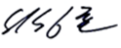
Written by | 26.Mar.2019 | H.KIM | 
 | Date | Name | Signature

Revision History
Issue | Page | Revision |  | Date
Issue | Page | Contents | Reference | Date
0 | All | First issue |  | 26.Mar.2019
1 |  | SDR off-set was modified | H.Kim
2 |  | SD data was modified | J.W.LEE | 26.Nov.2019

Contents
1. INTRODUCTION 4
1.1. LIST OF ABBREVIATIONS 4
2. GENERAL 5
2.1. MVB Specification 5
2.2. MVB Connection 6
2.3. MVB Telegram 6
2.4. Train Formation of Cairo3 8
3. DATA EXCHANGE 10
3.1. TCMS → APS SDR (Status Data Request) 10
3.1.1. TCMS-APS-SDR 10
3.2. APU → TCMS SD(Status Data) 12
3.2.1. APUx-TCMS-SD 12

INTRODUCTION
This document describes the interface specification between TCMS(Train Control and Monitoring System) and APS(Auxiliary Power Unit) for GREATER CAIRO METRO LINE No.3 (Thawra Line) project.

LIST OF ABBREVIATIONS
TCN Train Control Network
MVB Multifunction Vehicle Bus
EMD Electrical Medium Distance
WTB Wire Train Bus
TCMS Train Control and Monitoring System
CCU Central Control Unit
VCU Vehicle Control Unit
IO-M remote IO Module
VVVF Variable Voltage Variable Frequency
DU Display Unit
RTD Remote Transmission Device
DCU Door Control Unit
ATP Automatic Train Protection
EBCU Electrical Brake Control Unit
VAC Ventilation Air conditioner Controller
TCU Traction Control Unit
APU Auxiliary Power Unit
EVR Event Recorder
HCR Header Car Relay
MF Major Fault
MCF Major Complementary Fault
HSCB High Speed Circuit Breaker
LB Line Bus Switch
PB Parking Brake
EB Emergency Brake
HB Holding Brake
FSB Full Service Brake
AUTO Automatic Mode
ADB All Door Bypass
ADC All Door Closed
AAU Automatic Announcement Unit
DCU Display Control Unit(for PA/PIS)
BC Battery Charger
HCR Head Control Relay
SDR Status Data Request
SD Status Data

GENERAL

MVB Specification
General specification of MVB is described as follow.
-. Redundancy : Line A, Line B
-. Master / Slave : TCMS is only Master.
The subsystem needs not to act as bus administrator.
-. Media Support : EMD(Electrical Middle Distance) Communication Distance within 200m
<Table 1 Summary of the Multifunction Vehicle Bus by IEC 61375-1>
topology | bus(electrical)  star(optical)
Media | Electrical Short Distance  Electrical Middle Distance  Optical Glass Fibre | twisted wire pair, biased RS-485  shielded twisted wire pair, transformer coupled  200/240 µm fibres and star coupler
Length | Electrical Short Distance  Electrical Middle Distance  Optical Glass Fibre | 20 m, 32 devices per segment  200 m, 32 devices per segment  2000 m
Physical Redundancy | duplicated physical medium(synchronous send)
Signalling | Manchester II, 9-bit frame Start Delimiter
Signalling rate | 1.5 Mbit/s
Address space | 12-bit Device Address  (0…255 reserved for devices with Message Data capability)  12-bit Logical Address for Process Data  (each 16…256 bits)
Physical Addressing | single cast and broadcast
Frame size  (useful data) | 16, 32, 64, 128, 256 bits
Integrity | CRC-8 per 64bits + Manchester encoding, different frame Start Delimiter for Master Frame and Slave Frame against synchronization slip, reception time window supervision
Medium Allocation | by one centralized Master(Hyundai-Rotem’s CCU & VCU)
Traffic | periodic(mainly for Process Data)  sporadic(mainly for Message Data)  supervisory(for Supervisory Data)
Mastership Transfer | mastership transfer by token passing  serveral Bus Administrators can become Master in turn
Mastership Redundancy  (Option) | redundant Bus Administrators serve as back-up
Link Layer Service | Link Process Data Interface  Link Message Data Interface  Link Supervision Interface |  | broadcast of source addressed data  datagrams  Link Layer Management

MVB Connection
Where interchangeability is required, Subsystems connected by MVB shall be attached to the cable as follow:
<Table 2 Pin assignment for the EMD Connector>
1 | A.Data_P positive wire of Line A | 6 | A.Term_P, Positive pole of Terminator Line A
2 | A.Data_N negative wire of Line A | 7 | A.Term_N, Negative pole of Terminator Line A
3 | Not Used | 8 | B.Term_P, Positive pole of Terminator Line B
4 | B.Data_P positive wire of Line B | 9 | B.Term_N, Negative pole of Terminator Line B
5 | B.Data_N negative wire of Line B
Note 1 It is recommend to arrange the two connectors side by side on a device, Connector 1 on the left and Connector 2 on the right, to thread the wiring neatly.
Note 2 It may be necessary to ensure that the connector case is isolated from the device case if connection of the device cases is not advisable, for instance when large stray currents are expected.
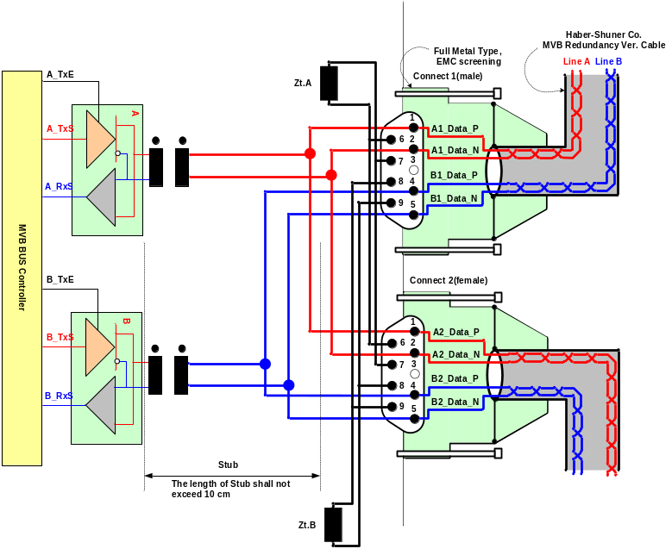
Figure 1 Double line EMD connector arrangement

MVB Telegram
There are 16 telegrams types on the MVB, which are distinguished by the F-code in Master Frame, as shown in Table 3.
Table 3 F-code of the MVB(Master Frame Type)

F-Code | Telegram Type
0 | Process Data Request with 16 bits
1 | Process Data Request with 32 bits
2 | Process Data Request with 64 bits
3 | Process Data Request with 128 bits
4 | Process Data Request with 256 bits
5 | (reserved)
6 | (reserved)
7 | (reserved)
8 | Mastership Transfer Request
9 | General Event Request
10 | (reserved)
11 | (reserved)
12 | Message Data Request
13 | Group Event Request
14 | Single Event Request
15 | Device Status Request
The basic data type for MVB network between TCMS and sub-system is WORD. Physical address is not used.
The byte ordering is the Big-Endian(Motorola) but, all data is read like word. So, the subsystem side must change like example.
The byte order and bit order for a data are as follows.
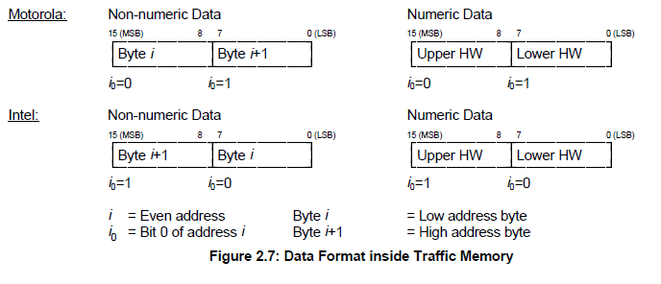
- MVB supervision :
The CCU is indicating the MVB state by the MVB watchdog counter that increases when the application is executed.
The counter from the MVB device is generated as soon as the application software is ready. If no MVB connection is established, i.e.
The MVB watchdog counter can not be received or an internal fault in the MVB device occurs, the signals, besides the watchdog counter, shall be had default value.
<Bit Ordering>
Data structures shall be numbered from left to right and from top to bottom, in the order of reading an English text. The first item on the top and to the left has offset zero.
WORD | Data Contents |  |  |  |  |  |  |  | Remark
WORD | Bit Mask |  |  |  |  |  |  |  | Remark
WORD | 15 | 14 | 13 | 12 | 11 | 10 | 9 | 8
WORD | 7 | 6 | 5 | 4 | 3 | 2 | 1 | 0
0 | 0 | 1 | 2 | 3 | 4 | 5 | 6 | 7
0 | 8 | 9 | 10 | 11 | 12 | 13 | 14 | 15
1 | 16 | 17 | 18 | 19 | 20 | 21 | 22 | 23
1 | 24 | 25 | 26 | 27 | 28 | 29 | 30 | 31
2 | 32 | 33 | 34 | 35 | 36 | 37 | 38 | 39
2 | 40 | 41 | 42 | 43 | 44 | 45 | 46 | 47
3 | 48 | 49 | 50 | 51 | 52 | 53 | 54 | 55
3 | 56 | 57 | 58 | 59 | 60 | 61 | 62 | 63
4 | 64 | 65 | 66 | 67 | 68 | 69 | 70 | 71
4 | 72 | 73 | 74 | 75 | 76 | 77 | 78 | 79
5 | 80 | 81 | 82 | 83 | 84 | 85 | 86 | 87
5 | 88 | 89 | 90 | 91 | 92 | 93 | 94 | 95
6 | 96 | 97 | 98 | 99 | 100 | 101 | 102 | 103
6 | 104 | 105 | 106 | 107 | 108 | 109 | 110 | 111
7 | 112 | 113 | 114 | 115 | 116 | 117 | 118 | 119
7 | 120 | 121 | 122 | 123 | 124 | 125 | 126 | 127
8 | 128 | 129 | 130 | 131 | 132 | 133 | 134 | 135
8 | 136 | 137 | 138 | 139 | 140 | 141 | 142 | 143
9 | 144 | 145 | 146 | 147 | 148 | 149 | 150 | 151
9 | 152 | 153 | 154 | 155 | 156 | 157 | 158 | 159
10 | 160 | 161 | 162 | 163 | 164 | 165 | 166 | 167
10 | 168 | 169 | 170 | 171 | 172 | 173 | 174 | 175
11 | 176 | 177 | 178 | 179 | 180 | 181 | 182 | 183
11 | 184 | 185 | 186 | 187 | 188 | 189 | 190 | 191
12 | 192 | 193 | 194 | 195 | 196 | 197 | 198 | 199
12 | 200 | 201 | 202 | 203 | 204 | 205 | 206 | 207
13 | 208 | 209 | 210 | 211 | 212 | 213 | 214 | 215
13 | 216 | 217 | 218 | 219 | 220 | 221 | 222 | 223
14 | 224 | 225 | 226 | 227 | 228 | 229 | 230 | 231
14 | 232 | 233 | 234 | 235 | 236 | 237 | 238 | 239
15 | 240 | 241 | 242 | 243 | 244 | 245 | 246 | 247
15 | 248 | 249 | 250 | 251 | 252 | 253 | 254 | 255

Train Formation of Cairo3
The train formation consists of 8 cars and can be seen in following figure. The detail arrangement is DTC-MC1-MC2-MCI-MCI-MC2-MC1-DTC. The two CCUs(Central Control Unit) are installed in both DTC, two VCUs are installed in MCI and two IO-Ms are installed in MC. CCU and VCU(Vehicle Control Unit) is connected to subsystem via MVB(Multifunction Vehicle Bus), WTB(Wire Train Bus) is used by the data communication interface between CCU and VCU.

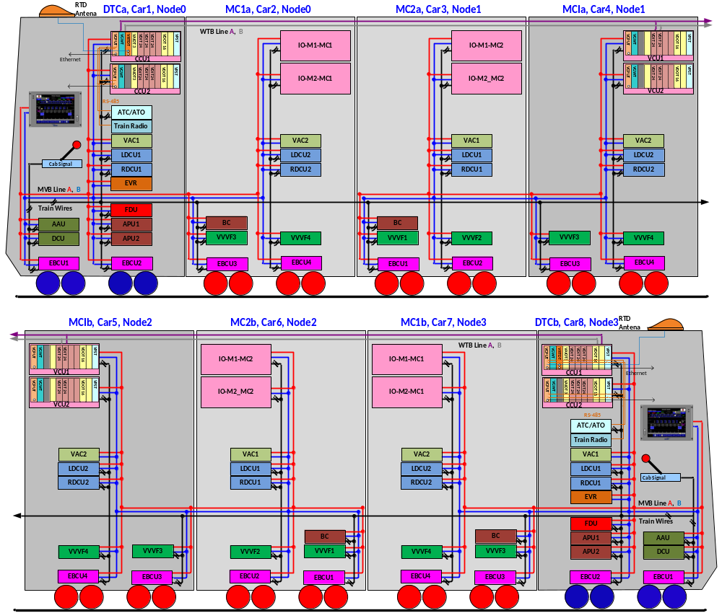

Figure 2 Configuration

DATA EXCHANGE

TCMS → APS SDR (Status Data Request)
Telegram name | Source | Sink | Port address | Fcode | Task | Remark
TCMS-APU-SDR | TCMS | APU ALL | 0x9C | 4

TCMS-APS-SDR
WORD | Data Contents |  |  |  |  |  |  |  | Remark
WORD | Bit Mask |  |  |  |  |  |  |  | Remark
WORD | 15 | 14 | 13 | 12 | 11 | 10 | 9 | 8
WORD | 7 | 6 | 5 | 4 | 3 | 2 | 1 | 0
0 | WatchDogCounterTCMS
1 | DateTimeYear
1 | DateTimeMonth
2 | DateTimeDay
2 | DateTimeHour
3 | DateTimeMinute
3 | DateTimeSec
4 | DateTimeValid |  |  |  | MVB_Node3(car7/8) | MVB_Node2(car5/6) | MVB_Node1(car3/4) | MVB_Node0(car1/2)
5
6
7
8
9
10
11
12
13
14
15

Bit  Offset | Data  Size | Data  Type | Data Name | Contents | Remarks
0 | 16 | UNSIGNED16 | WatchDogCounterTCMS | TCMS watchdog counter(0~65535)
16 | 8 | UNSIGNED8 | DateTimeYear | Year (00 – 99), | BCD
24 | 8 | UNSIGNED8 | DateTimeMonth | Month (1 – 12) | BCD
32 | 8 | UNSIGNED8 | DateTimeDay | Day (1 – 31) | BCD
40 | 8 | UNSIGNED8 | DateTimeHour | Hour (0 -23) | BCD
48 | 8 | UNSIGNED8 | DateTimeMinute | Minute (0 – 59) | BCD
56 | 8 | UNSIGNED8 | DateTimeSec | Second (0 – 59) | BCD
64 | 1 | BOOL | DateTimeValid | 0/1, 1 = Date & Time Validation
65 | 1 | BOOL
66 | 1 | BOOL
67 | 1 | BOOL
68 | 1 | BOOL | MVB_Node3(car7/8) | MVB NODE3 position(Refer to Fig2)
69 | 1 | BOOL | MVB_Node2(car5/6) | MVB NODE2 position(Refer to Fig2)
70 | 1 | BOOL | MVB_Node1(car3/4) | MVB NODE1 position(Refer to Fig2)
71 | 1 | BOOL | MVB_Node0(car1/2) | MVB NODE0 position(Refer to Fig2)

APU → TCMS SD(Status Data)
Telegram name | Source | Sink | Port address | Fcode | Task | Remark
APU1-TCMS-SD | APU1 | TCMS | 0x90 | 4 | T(≤256ms)
APU2-TCMS-SD | APU2 | TCMS | 0x94 | 4 | T(≤256ms)

APUx-TCMS-SD
WORD | Data Contents |  |  |  |  |  |  |  | Remark
WORD | Bit Mask |  |  |  |  |  |  |  | Remark
WORD | 15 | 14 | 13 | 12 | 11 | 10 | 9 | 8
WORD | 7 | 6 | 5 | 4 | 3 | 2 | 1 | 0
0 | APU_WatchdogCounter(0 ~ 65535, 0000 - FFFFH, 1/bit)
1 | Input Voltage (0 ~ 1,500V, 00 - FAH, 6V/bit)
1 | Input Current (0 ~ 500A, 00 – FAH, 2A/bit)  Input Current (0 ~ 1000A, 00 - FAH, 4A/bit)
2 | Boost Output Voltage (0 ~ 1,500V, 00 - FAH, 6V/bit)
2 | Boost Output Current (0 ~ 500A, 00 - FAH, 2A/bit)
3 | Inverter Input Voltage (0 ~ 1,500V, 00 - FAH, 6V/bit)
3 | Inverter Input Current (0 ~ 500A, 00 – FAH, 2A/bit)  Inverter Input Current (0 ~ 1000A, 00 - FAH, 4A/bit)
4 | Inverter Output Voltage (0 ~ 500V, 00 – FAH, 2V/bit)  Inverter Output Voltage (0 ~ 1000V, 00 - FAH, 4V/bit)
4 | Inverter Output Current (0 ~ 500A, 00 – FAH, 2A/bit)  Inverter Output Current (0 ~ 1000A, 00 - FAH, 4A/bit)
5 | Inverter Output Frequency (0 ~ 125Hz, 00 - FAH, 0.5Hz/bit)
5 | Spare
6 | Spare
6 | Spare
7 | WHM (0 ~ 6553.5 kWh, 0000 - FFFFH, 0.1kWh/bit )
8 | ID | START  on | CHKa | LKa | OUTKa | PPRa | RESET | Spare  APU OFF | STATUS
8 | BSTPWM | DCPWM | INVPWM | Spare | Spare | Spare | Spare | Spare  MODE | STATUS
9 | BHGDF | BLGDF | DUXGDF | DVYGDF | IUXGDF | IVYGDF | IWZGDF | Spare | FAULT
9 | INOVF | BOOVF | BOUVF | BOUBF | IIOVF | IIUVF | IOOVF | IOUVF | FAULT
10 | INOCF | BOOCF | IIOCF  Spare | IOOCF  IIOCF | PCDF | CPSF | Spare  GRF | Spare | FAULT
10 | MJF | OVLD | THF | CHKF | LKF | SIVKF  OUTKF | PPRF | Spare | FAULT
11 | Ver(0~250, 00 – FAH, 0.1/bit)  Ver (0.0 ~ 9.9, 00 - 63H, 0.1/bit) |  |  |  |  |  |  |  | S/W VERSION
11 | Spare |  |  |  |  |  |  |  | S/W VERSION
12 | Spare | Spare | Spare | Spare | Spare | Spare | Spare | Spare
12 | Spare | Spare | Spare | Spare | Spare | Spare | Spare | Spare
13 | Spare | Spare | Spare | Spare | Spare | Spare | Spare | Spare
13 | Spare | Spare | Spare | Spare | Spare | Spare | Spare | Spare
14 | Spare | Spare | Spare | Spare | Spare | Spare | Spare | Spare
14 | Spare | Spare | Spare | Spare | Spare | Spare | Spare | Spare
15 | Spare | Spare | Spare | Spare | Spare | Spare | Spare | Spare
15 | Spare | Spare | Spare | Spare | Spare | Spare | Spare | Spare

Bit  Offset | Data  Size | Data  Type | Data Name | Contents | Remarks
0 | 16 | UNSIGNED16 | APU_WatchdogCounter | -. Range: 0 to 65535 (0000h to FFFFh)  -. APU increments this bit every transmission cycle. TCMS ignores the information of SD if this counter is not incremented for more than "1000ms". | Word00
16 | 8 | UNSIGNED8 | Input Current | -. Range: 0 to 500A (00h to FAh, 2A/bit)  -. Range: 0 to 1000A (00h to FAh, 4A/bit) | Word01
24 | 8 | UNSIGNED8 | Input Voltage | -. Range: 0 to 1500V (00h to FAh, 6V/bit) | Word01
32 | 8 | UNSIGNED8 | Boost Output Current | -. Range: 0 to 500A (00h to FAh, 2A/bit) | Word02
40 | 8 | UNSIGNED8 | Boost Output Voltage | -. Range: 0 to 1500V (00h to FAh, 6V/bit) | Word02
48 | 8 | UNSIGNED8 | Inverter Input Current | -. Range: 0 to 500A (00h to FAh, 2A/bit)  -. Range: 0 to 1000A (00h to FAh, 4A/bit) | Word03
56 | 8 | UNSIGNED8 | Inverter Input Voltage | -. Range: 0 to 1500V (00h to FAh, 6V/bit) | Word03
64 | 8 | UNSIGNED8 | Inverter Output Current | -. Range: 0 to 500A (00h to FAh, 2A/bit)  -. Range: 0 to 1000A (00h to FAh, 4A/bit) | Word04
72 | 8 | UNSIGNED8 | Inverter Output Voltage | -. Range: 0 to 500V (00h to FAh, 2V/bit)  -. Range: 0 to 1000V (00h to FAh, 4V/bit) | Word04
80 | 8 | UNSIGNED8 | Spare | -. Spare | Word05
88 | 8 | UNSIGNED8 | Inverter Output Frequency | -. Range: 0 to 125Hz (00h to Fah, 0.5Hz/bit) | Word05
96 | 8 | UNSIGNED8 | Spare | -. Spare | Word06
104 | 8 | UNSIGNED8 | Spare | -. Spare | Word06
112 | 16 | UNSIGNED16 | Watt-hour meter for power consumption | -. Range: 0 to 6553.5kWh (0000h to FFFFh)  -. When this value exceeds 6553.5kWh (FFFFh), it will be reset to 0kWh (0000h).  -. This value will be reset to 0kWh when APU is powered off. | Word07
128 | 1 | BOOL | Spare  MODE | -. Spare  -.HIGH(1): Normal Mode, LOW(0): TEST Mode | Word08
129 | 1 | BOOL | RESET  Spare | -. HIGH(1) : RESET  -. Spare | Word08
130 | 1 | BOOL | PPRa  Spare | -. HIGH(1) : PPR(Phase Protection Relay) ON  -. Spare | Word08
131 | 1 | BOOL | OUTKa  Spare | -. HIGH(1) : OUTK(AC Output Contactor) Exciting Coil ON  -. Spare | Word08
132 | 1 | BOOL | LKa  Spare | -. HIGH(1) : LK(Line Contactor) Exciting Coil ON  -. Spare | Word08
133 | 1 | BOOL | CHKa  INVPWM | -. HIGH(1) : CHK(Charging Contactor) Exciting Coil ON  -. HIGH(1) : Inverter IGBT Gate ON | Word08
134 | 1 | BOOL | START ON  DCPWM | -. HIGH(1) : Start on status  -. HIGH(1) : DCDC Converter IGBT Gate ON | Word08
135 | 1 | BOOL | ID  BSTPWM | -. HIGH(1) : ID(1), LOW(0) : ID(0)  -. HIGH(1) : Boost Converter IGBT Gate ON | Word08
136 | 1 | BOOL | Spare  APU OFF | -. Spare  -.HIGH(1): APU OFF signal received status | Word08
137 | 1 | BOOL | Spare  RESET | -. Spare  -. HIGH(1) : RESET | Word08
138 | 1 | BOOL | Spare  PPRa | -. Spare  -. HIGH(1) : PPR(Phase Protection Relay) ON | Word08
139 | 1 | BOOL | Spare  OUTKa | -. Spare  -. HIGH(1) : OUTK(AC Output Contactor) Exciting Coil ON | Word08
140 | 1 | BOOL | Spare  LKa | -. Spare  -. HIGH(1) : LK(Line Contactor) Exciting Coil ON | Word08
141 | 1 | BOOL | INVPWM  CHKa | -. HIGH(1) : Inverter IGBT Gate ON  -. HIGH(1) : CHK(Charging Contactor) Exciting Coil ON | Word08
142 | 1 | BOOL | DCPWM  START ON | -. HIGH(1) : DCDC Converter IGBT Gate ON  -. HIGH(1) : Start on status. | Word08
143 | 1 | BOOL | BSTPWM  ID | -. HIGH(1) : Boost Converter IGBT Gate ON  -. HIGH(1) : ID(1), LOW(0) : ID(0) | Word08
144 | 1 | BOOL | IOUVF | -.HIGH(1) : Inverter output under voltage detection | Word09
145 | 1 | BOOL | IOOVF | -.HIGH(1) : Inverter output over voltage detection | Word09
146 | 1 | BOOL | IIUVF | -.HIGH(1) : Inverter Input under voltage detection | Word09
147 | 1 | BOOL | IIOVF | -.HIGH(1) : Inverter Input over voltage detection | Word09
148 | 1 | BOOL | BOUBF | -.HIGH(1) : Boost Output voltage unbalance detection | Word09
149 | 1 | BOOL | BOUVF | -.HIGH(1) : Boost Output under voltage detection | Word09
150 | 1 | BOOL | BOOVF | -.HIGH(1) : Boost Output over voltage detection | Word09
151 | 1 | BOOL | INOVF | -.HIGH(1) : Input over voltage detection | Word09
152 | 1 | BOOL | Spare | -. Spare | Word09
153 | 1 | BOOL | IWZGDF | -.HIGH(1) : Gate Driver Failure, Inverter WZ | Word09
154 | 1 | BOOL | IVYGDF | -.HIGH(1) : Gate Driver Failure, Inverter VY | Word09
155 | 1 | BOOL | IUXGDF | -.HIGH(1) : Gate Driver Failure, Inverter UX | Word09
156 | 1 | BOOL | DVYGDF | -.HIGH(1) : Gate Driver Failure, DCDC Converter VY | Word09
157 | 1 | BOOL | DUXGDF | -.HIGH(1) : Gate Driver Failure, DCDC Converter UX | Word09
158 | 1 | BOOL | BLGDF | -.HIGH(1) : Gate Driver Failure, Boost L | Word09
159 | 1 | BOOL | BHGDF | -.HIGH(1) : Gate Driver Failure, Boost H | Word09
160 | 1 | BOOL | Spare | -. Spare | Word10
161 | 1 | BOOL | PPRF | -.HIGH(1) : Phase collision detection Relay fault detection | Word10
162 | 1 | BOOL | OUTKF | -.HIGH(1) : AC Output Contactor fault detection | Word10
163 | 1 | BOOL | LKF | -.HIGH(1) : Line Contactor fault detection | Word10
164 | 1 | BOOL | CHKF | -.HIGH(1) : Charging Contactor fault detection | Word10
165 | 1 | BOOL | THF | -.HIGH(1) : Stack over temperature detection | Word10
166 | 1 | BOOL | OVLD | -.HIGH(1) : AC output over load detection | Word10
167 | 1 | BOOL | MJF | -.HIGH(1) : Major Failure happened | Word10
168 | 1 | BOOL | Spare | -. Spare | Word10
169 | 1 | BOOL | Spare  GRF | -. Spare  -.HIGH(1): GRound Current failure detection | Word10
170 | 1 | BOOL | CPSF | -.HIGH(1) : Control Power Supply failure detection | Word10
171 | 1 | BOOL | PCDF | -.HIGH(1) : Phase collision detection | Word10
172 | 1 | BOOL | IIOCF | -.HIGH(1) : Inverter Input over current detection | Word10
173 | 1 | BOOL | Spare | -. Spare | Word10
174 | 1 | BOOL | BOOCF | -.HIGH(1) : Boost Output over current detection | Word10
175 | 1 | BOOL | INOCF | -.HIGH(1) : Input over current detection | Word10
176 | 8 | UNSIGNED8 | Spare | -. Spare | Word11
184 | 8 | UNSIGNED8 | Ver | -. Version  -. 0 ~ 250, 00 – FAH, 0.1/bit  -. 0.0 ~ 9.9, 00 – 63H, 0.1/bit  -. Ex) 00H = Ver 0.0  -. Ex) 0AH = Ver 1.0 | Word11
192 | 8 | UNSIGNED8 | Spare | -. Spare | Word12
200 | 8 | UNSIGNED8 | Spare | -. Spare | Word12
208 | 8 | UNSIGNED8 | Spare | -. Spare | Word13
216 | 8 | UNSIGNED8 | Spare | -. Spare | Word13
224 | 8 | UNSIGNED8 | Spare | -. Spare | Word14
232 | 8 | UNSIGNED8 | Spare | -. Spare | Word14
240 | 8 | UNSIGNED8 | Spare | -. Spare | Word15
248 | 8 | UNSIGNED8 | Spare | -. Spare | Word15

